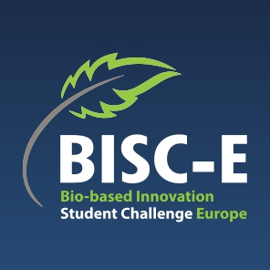

Bio-Based Innovation Students Challenge – Europe 2024

Dossier

Team name
Project Title
Team Leader
Team member 2
Team member 3
Team member 4
Team member 5
Team member 6

Supervisor
Supervisor’s position:

- Short description of the Innovation
Max 150 words. Could be used in communication on internet and social media

- Introduction and explanation of the innovative aspects
Max 500 words/ 1 A4 including illustrations (optional).

- Technical explanation of the innovation
Max 2 A4 including illustrations (optional).

- Elaboration of the positive environmental aspects
Max 2 A4 including illustrations (optional).

- Economic viability of the innovation
Max 2 A4 including illustrations (optional).

